Homework 2 – ITEC 3150, Fall 2021

Due Date:

Friday, September 24, 2021 by 6 PM

I will accept assignments until Sunday, September 26, 2021 at 11:50 PM, but no assignments accepted after that except under exceptional circumstances.

Competencies:

Inheritance

JavaFX

Binary File Reading (ObjectInputStream)

Given Files- DO NOT CHANGE EXCEPT TO ADD PACKAGE INFO:

Pet.java

Dog.java – May change toString()

Cat.java – may change toString()

BuildInputFile.java

Be sure to turn in Pet, Dog and Cat class with your homework submission.

Problem Statement:

Using the given files, create a pets.dat file by running BuildinputFile.java. The .dat file will be part of your turned in project, but BuildInputFile.java is provided only to create the .dat file for you once you set up your IDE project and does not need to be turned in.

Create a JavaFX program that reads in the file pets.dat and displays them in a ListView node similar to the one shown here. Yours should show the names of the Dog and Cat objects read in from the file- not the names shown here. The title should read Available Pets

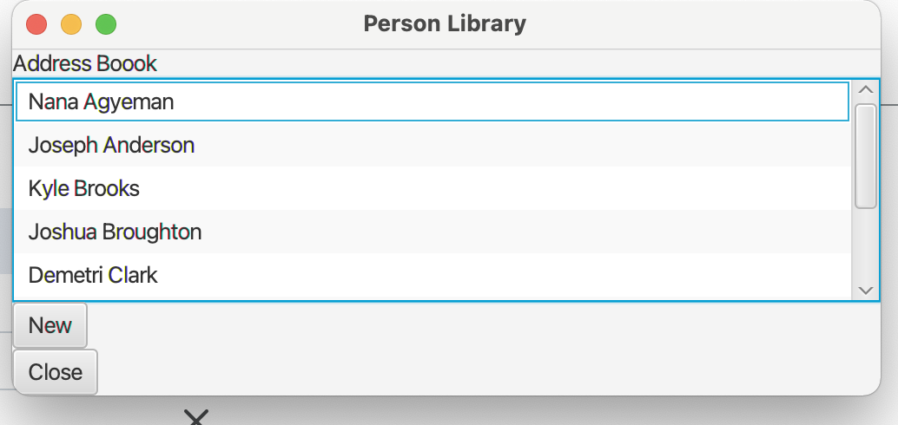

When the New button is closed it should allow for the input of a new Dog or Cat in a separate Stage- similar to this new Person GUI. Yours should provide separate inputs for the differences between Dogs and Cats.

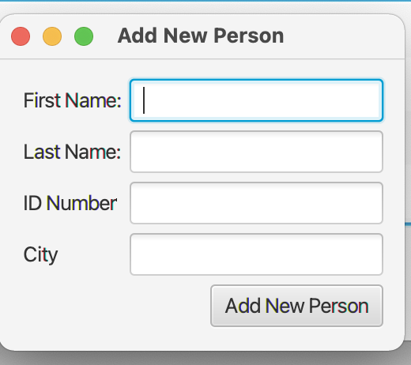

The second Stage should close once Add New Pet button is pushed.

When the name on the original List is double clicked another Stage should pop up showing the values of ALL the attributes of the Dog or Cat. Again, here is Person.

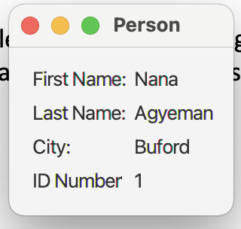

The code for the Person version is available in D2L content under Example for Homework 2.

No rewriting of the file is required in this assignment. But up to 10 extra credits if original file is overwritten with new added Pet objects.

Grading Criteria:

|  |  |
| --- | --- |
| Criteria | Points |
| Coding Standards | 15 |
| Read in binary file containing list of Pet objects | 15 |
| Display Pet List in JavaFx GUI | 25 |
| Open second stage displaying detail information of Pet (must show Dog/Cat differences) | 15 |
| Allow Entry of new Dog or Cat to list | 15 |
| JavaFX GUI’s Readable and user friendly | 10 |